REVIEW 2 – REQUIREMENTS ANALYSIS
Resilient Multi-Peer File Distribution & Recovery Engine
Team 13 | Guide: Prof. MS Pooja P Shettar
Field | Student Entry
Team No. | 13
Project Theme / Title | Resilient Multi-Peer File Distribution & Recovery Engine
Guide Name | Prof. MS Pooja P Shettar
Date Prepared | 03 November 2026

Team Members
Sl. No. | SRN | Student Name
1 | 01FE24BCI093 | Vineet S Kulkarni
2 | 01FE24BCI113 | Manasa B Vasare
3 | 01FE24BCI116 | Mahadev Pawar
4 | 01FE24BCI092 | Arihant A Narayankar

Section 1: Functional Requirements
FR ID | Description | Priority  (Mandatory / Challenge) | Source Need
FR-01 | The system shall allow a user to select a file for storage or transfer. | Mandatory | File upload / distribution
FR-02 | The system shall divide the selected file into smaller fixed-size chunks for distributed storage. | Mandatory | Manageable distributed transfer
FR-03 | The system shall assign a unique identifier and sequence number to each generated chunk. | Mandatory | Chunk identification and correct reconstruction
FR-04 | The system shall generate and store a hash for each chunk to verify data integrity. | Mandatory | Detect corruption
FR-05 | The system shall maintain membership information for participating peers. | Mandatory | Know available storage / transfer nodes
FR-06 | The system shall enable peers to communicate using TCP-based request and response messages. | Mandatory | Reliable peer communication
FR-07 | The system shall distribute file chunks across available peers. | Mandatory | Multi-peer file distribution
FR-08 | The system shall create and maintain replicas of chunks on multiple peers for fault tolerance. | Mandatory | Survive supported peer failures
FR-09 | The system shall detect peer failures using heartbeat responses and timeout conditions. | Mandatory | Detect unavailable peers
FR-10 | The system shall select an eligible surviving replica as the source for chunk recovery. | Mandatory | Recover data after a peer failure
FR-11 | The system shall identify chunks that are unavailable, corrupted, or affected by a peer failure. | Mandatory | Locate affected data
FR-12 | The system shall recover an affected chunk from a valid surviving replica. | Mandatory | Replica-based recovery
FR-13 | The system shall detect interrupted transfers, discard incomplete data, and retry the affected chunk transfer. | Mandatory | Handle transfer interruption
FR-14 | The system shall verify each recovered chunk by comparing its computed hash with the stored hash. | Mandatory | Validate recovered data
FR-15 | The system shall reject invalid or corrupted recovery results and retry using another eligible source when available. | Mandatory | Prevent acceptance of corrupt chunks
FR-16 | The system shall reconstruct the original file by ordering verified chunks according to sequence numbers and concatenating them. | Mandatory | Correct file retrieval
FR-17 | The system shall report an unrecoverable condition when no valid surviving source is available. | Mandatory | Explicitly handle unrecoverable data
FR-18 | The system shall record system events, failure detection, recovery activity, integrity results, retries, and performance metrics. | Mandatory | Evaluate reliability and performance

Section 2: Non-Functional Requirements
NFR ID | Description | Category | Measurable Target
NFR-01 | The system shall preserve successfully stored file data within the configured replication and supported peer-failure model. If no valid copy survives, it shall report the file/chunk as unrecoverable rather than silently claiming success. | Reliability | 100% of tested unrecoverable cases are explicitly reported; no failed recovery is reported as successful.
NFR-02 | The system shall verify every received/recovered chunk against its stored integrity hash before accepting it. | Integrity | 100% of accepted chunks pass hash verification; a deliberately modified chunk is rejected in the hash-mismatch test.
NFR-03 | The system shall recover affected chunks after supported peer failures when at least one valid replica remains reachable. | Fault tolerance | Initial target: successful recovery in ≥95% of eligible test cases. Exclude cases where no valid replica survives; validate with repeated controlled trials.
NFR-04 | The system shall mark an unresponsive peer unavailable within the specified detection target under the agreed test configuration. | Performance | Initial target: ≤2 seconds from simulated peer failure to unavailable-state notification. Record heartbeat interval, timeout, peer count and network conditions.
NFR-05 | The system shall measure recovery latency and report it by file size and peer count; a fixed pass threshold shall be set after baseline experiments. | Performance | Record elapsed time from failure/missing-chunk detection to verified chunk restoration for every trial. Report median and 95th percentile; approve a pass threshold only after baseline experiments.
NFR-06 | The system shall maintain modular interfaces so each of the six engines can be tested independently and integrated through defined inputs/outputs. | Maintainability / modularity | E1–E6 each pass component tests; integration tests verify the documented engine interfaces.
NFR-07 | The system shall produce repeatable outcomes for the same input files, configuration and peer-state sequence. | Repeatability | Across repeated runs with the same configuration, chunk boundaries, sequence ordering and correctness outcome are identical. Placement is deterministic when peer order is unchanged.
NFR-08 | The system shall reconstruct a file without missing, duplicated or reordered verified chunks. | Correctness | 100% byte-for-byte equality between original and reconstructed files for every successful reconstruction test, verified by file hash and/or byte comparison.

Measurement qualification: The ≥95% recovery-success and ≤5-second failure-detection values are initial engineering targets from the Gate 1 material, not measured results. Recovery-latency pass thresholds remain pending baseline experiments. Reliability is bounded by the configured replication and supported peer-failure model.

Section 3: Use Cases
ID | Actor | Description / User Story | Main Flow | Exception Flow
UC-01 | User | Upload file for distribution | Select file; system chunks it, assigns IDs/sequences, hashes chunks and starts distribution. | Invalid/unreadable file: reject with an error; do not mark upload successful.
UC-02 | Peer | Join/register in network | Peer supplies IP/port and joins; membership information is updated. | Duplicate/unreachable peer: reject or mark unavailable; retain accurate membership state.
UC-03 | Peer | Announce availability | Peer announces it can participate; status is reflected in peer metadata. | No response or disconnect: E4 eventually marks peer unavailable after timeout.
UC-04 | System / Peer | Distribute and store chunks | E3 selects peers using round-robin placement and stores configured replicas. | Target peer unavailable: do not record successful placement; retry or report placement failure.
UC-05 | User | Request file for retrieval | User requests file; system finds chunk metadata and requests chunks from peers. | Chunk missing or peer unavailable: invoke recovery from another eligible replica.
UC-06 | System | Verify chunk integrity | Compute hash of received chunk and compare with stored hash. | Hash mismatch: reject chunk and try another eligible source.
UC-07 | System / Peer | Handle missing chunk | Identify affected chunk, look up replicas, request from a surviving peer and verify. | No valid surviving replica: report unrecoverable condition.
UC-08 | System | Reconstruct file | Order verified chunks by sequence number and concatenate them. | Missing/duplicate sequence or incomplete set: do not report successful reconstruction.
UC-09 | System / Maintainer | Review monitoring and evaluation | Record detection/recovery events, integrity results, retries, bytes and timings. | Logging failure: report the limitation; do not silently claim metrics were captured.

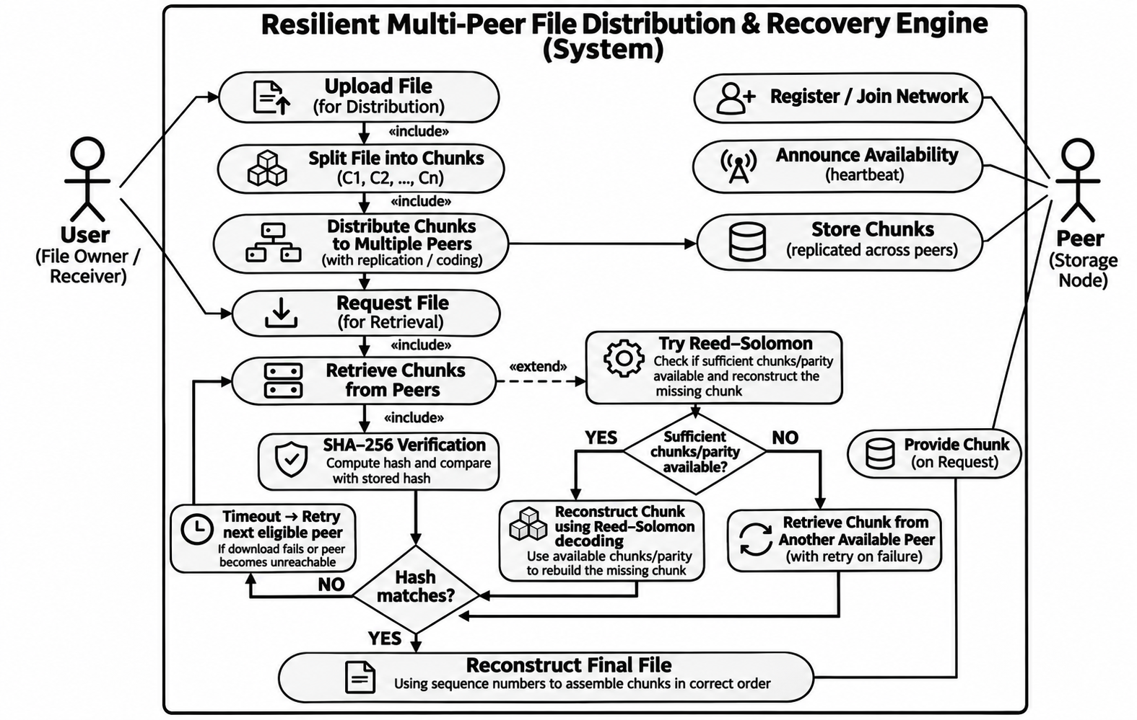

Fig.: Use-case overview adapted from the Gate 1 use-case set. The diagram summarizes user upload/retrieval actions, peer participation, chunk distribution, integrity verification, recovery and reconstruction.

Section 4: Acceptance Criteria
Requirement ID | Acceptance Criteria | Test / Verification Method
FR-01 | A supported test file can be selected; unreadable or missing input is rejected with a clear error. | Manual/UI test; valid and invalid file cases.
FR-02 | Chunks cover the input bytes exactly once; all chunks except possibly the last have the configured fixed size. | Chunk-size and byte-coverage test.
FR-03 | Every chunk has a unique ID within the file and a sequence number that reflects original order. | Metadata uniqueness/order assertion.
FR-04 | A hash is stored for every generated chunk and is reproducible for unchanged chunk bytes. | Hash recomputation test.
FR-05 | Joining and leaving peers updates membership state accurately. | Peer registration/membership test.
FR-06 | Peers can exchange a framed request and response over TCP; connection errors/timeouts are surfaced. | TCP communication test.
FR-07 | Every chunk is assigned to an eligible peer and the placement map records the assignment. | Normal distribution test.
FR-08 | Each chunk has the configured number of distinct replicas when enough eligible peers are available. | Replica-count and placement test.
FR-09 | Under the agreed test configuration, a peer that stops responding is marked unavailable within the initial ≤2-second target. | Heartbeat/timeout test; record elapsed time, heartbeat interval, timeout and network conditions.
FR-10 | Recovery selects a source whose peer is available and whose metadata identifies a replica of the required chunk. | Source-selection test.
FR-11 | The system identifies chunks on failed peers and detects missing chunks or hash mismatches. | Peer-failure and hash-mismatch tests.
FR-12 | For a chunk with a valid surviving replica, the recovered bytes match the stored chunk hash. | Single-peer failure/recovery test.
FR-13 | After a transfer is interrupted, partial temporary data is discarded and a complete chunk transfer is retried. | Interrupt transfer mid-chunk; inspect retry and output.
FR-14 | No recovered chunk is accepted unless its computed hash matches the stored hash. | Hash-mismatch test; accepted corrupt chunks = 0.
FR-15 | A bad source is rejected; another eligible source is attempted; if none exists, unrecoverable status is reported. | Corrupt first replica / exhaust sources test.
FR-16 | Successful reconstruction is byte-for-byte identical to the original file. | Compare original and reconstructed files by bytes/hash.
FR-17 | When no valid source survives, the system reports unrecoverable status and does not claim success. | No-surviving-source test.
FR-18 | Logs include events, failure detection, recovery, integrity, retries, bytes transferred and relevant timings. | Inspect logs against generated test events.

Project Parameters and Scope Notes
- Chunk size: fixed-size chunking is part of the design, but the actual configured size is not specified in the supplied Gate 1 material.
- Replication factor: replicas are maintained on distinct peers, but the target number of copies and minimum peer count are not finalized.
- Peer failure detection: heartbeat and timeout detection are required; the exact heartbeat interval and timeout calculation remain to be defined.
- Recovery retry policy: maximum retries, per-request timeout and source-exclusion policy require implementation-level decisions.
- Recovery performance: record recovery latency by file size and peer count; establish a pass threshold only after baseline experiments.
- Metadata persistence: E6 is described as a shared metadata/monitoring service; database technology and metadata-service failure tolerance are not established.
- Security: authentication, authorization and encryption are not defined in the supplied Gate 1 requirements. Do not claim these as implemented or tested.
- Reed–Solomon: optional/planned extension only; no coding parameters or implementation are established in the supplied document.

